**Plan Arch**

Introduction

Welcome to the planning document for the "Arch Interaction" project, designed for the Glow Festival. This document outlines the strategic approach to enhancing visitor interaction through a dynamic architectural installation—The Arch. By integrating cutting-edge technology with innovative design, this project aims to create a captivating and interactive experience for festival attendees. Here, you will find detailed plans on the sensory engagement strategies, interactive features, and the technical specifications needed to bring this vision to life. Our goal is to not only attract visitors but to immerse them in an experience that blends art with technology, making their visit unforgettable.

Purpose

The purpose of this document is to provide a comprehensive blueprint of the "Arch Interaction" installation, detailing the components and technologies used to create an engaging environment. This includes an overview of the design concepts, the types of sensors selected for visitor interaction, and the considerations for sustainable power solutions. It serves as a guide for stakeholders to understand the objectives, the technological integration, and the expected outcomes of the installation.

Document Overview

Visual and Sensory Engagement: Describes the dynamic lighting effects and sensory feedback mechanisms that activate in response to visitor presence.

Interactive Features: Details the incorporation of capacitive touch sensors and motion sensors to create a responsive and engaging visitor experience.

Signage and First Impressions: Explains the importance of visually appealing signs and creative graphics to attract and retain the attention of visitors.

Powering the Installation: Discusses the sensor types, their power efficiency, and the feasibility of using solar power.

Implementation and Technical Aspects: Outlines the compatibility with Arduino for ease of integration and programming, and the steps for prototyping and testing.

By the end of this document, stakeholders should have a clear understanding of how the "Arch Interaction" installation will function, the technologies employed, and the impact it aims to have on the Glow Festival. This project is not just about creating a structure but about fostering an environment where technology enhances the human experience in public spaces.

**KPI’s**

Analysis-U1.2:

"By assessing the needs of visitors and translating these into technical solutions, the project aims to enhance visitor interaction through dynamic architectural installations."

Analysis-U1.3:

"This document reflects a deep dive into existing interactive concepts, such as the 'Rain Room' by Random International, which informed the sensor and lighting usage, aligning with best practices in interactive design."

Design-U1.2:

"The project involves designing usability tests to identify crucial interaction problems. These tests will be conducted during the prototype phase to ensure the installation's effectiveness in engaging visitors."

Design-U1.3:

"The document serves as a blueprint for applying a standard protocol in interaction design, guiding the development and integration of technological components within the arch."

Realisation-U1.1:

"The implementation section details the practical application of the design, ensuring that the interactive products are tested and adjusted according to established design guidelines, enhancing the arch's sensory and interactive capabilities."

Advise-U1.2:

"Based on usability analysis, recommendations have been made to optimize the interactive experience through strategic placement of sensors and innovative lighting effects, ensuring the project aligns with visitor expectations and needs."

**Attracting Visitors**

**Visual and Sensory Engagement:** Dynamic lighting effects that activate in response to visitor presence. Can be achieved by using sensors that detect movement, similar to the "Rain Room" by Random International. Such features can significantly attract and hold the attention of visitors.

[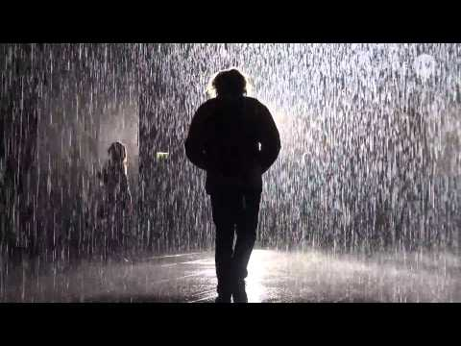](https://www.youtube.com/embed/tOARXy-f_GY?feature=oembed)

**Interactive:** Put on the arch capacitive touch sensors within the light fixtures, allowing visitors to adjust the brightness by touch. Additionally, incorporate motion sensors to dynamically respond to visitor movements. The idea is suitable for interactive installations and Arduino can be used, perfect for DIY (Do It Yourself).

**Just Sign**

First impressions really matter, especially when it comes to drawing people into an experience. Eye-catching signs, like bright displays or creative graphics. They catch the eye of passersby, sparking curiosity and drawing them in. Using bold, dynamic signs that might light up or interact can make the installation stand out, inviting people to explore further and making their visit memorable. This simple yet effective approach helps the installation attract more visitors and leave a lasting impression.

**Powering the Installation**

**Sensor Types:**

**Capacitive Touch Sensors:** Suitable for direct interaction with the arch. They consume low power, making them perfect for installations where direct contact will occur.

**PIR Sensors:** They are suitable for detecting the presence of visitors without direct contact. Efficient in terms of power usage and can cover broader areas.

**Pressure Plates:** Effective but may require more maintenance. Their durability in outdoor settings can be a problem, especially with many visitors.

**Power Efficiency:** Assess the energy consumption of each type of sensor. For interactions that involve direct contact, capacitive sensors are preferred due to their low power usage. For more general movement detection, PIR sensors are better.

**Solar Power Proposal:** While solar power is an eco-friendly option, its feasibility in terms of cost and practical installation needs further investigation.

**Implementation and Technical Aspects**

**Arduino Compatibility**: Ensure that the selected sensors are compatible with Arduino. This is crucial for the integration and programming of the installation.

**Prototype and Test:** Begin with a small-scale model using the chosen sensors to evaluate their effectiveness and energy consumption. Make adjustments based on these initial tests to optimize performance.

**Conclusion**

The proposed approach balances visual appeal with interactive and educational benefits, ensuring the installation is both attractive and functional. By choosing the right mix of sensors and focusing on sustainable power solutions, the interactive arch is set to be a standout feature in any public or exhibition space.